Procedural Markup Language

⚙️ What is a Procedural Markup Language?
# Source: AI Source: Provided by: [Data Path: Persons Table -> ID Column: 1, Name_En Column: Motasem Essam] -> From: [Chatgpt (GPT‑5 Mini)] on [1/26/2026]
Procedural markup is a type of markup language that tells a computer what to do — not just how content looks or what it means, but how to process it.

🔹 Key Idea:
# Source: AI Source: Provided by: [Data Path: Persons Table -> ID Column: 1, Name_En Column: Motasem Essam] -> From: [Chatgpt (GPT‑5 Mini)] on [1/26/2026]
Procedural markup contains instructions or commands for the formatting engine or interpreter — like a mini programming language inside a document.
It controls how a document is processed, rendered, or printed by defining steps or procedures, such as:
- Page layout
- Footnotes or references
- Conditional formatting
- Reusable macros

📄 Common Examples of Procedural Markup
# Source: AI Source: Provided by: [Data Path: Persons Table -> ID Column: 1, Name_En Column: Motasem Essam] -> From: [Chatgpt (GPT‑5 Mini)] on [1/26/2026]
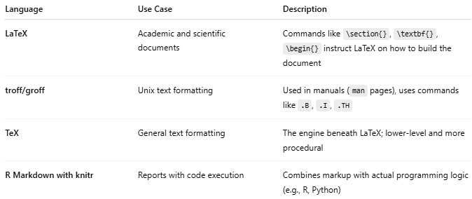
Language | Use Case | Description
LaTeX | Academic and scientific documents | Commands like \section{}, \textbf{}, \begin{} instruct LaTeX on how to build the document
troff/groff | Unix text formatting | Used in manuals (man pages), uses commands like .B, .I, .TH
TeX | General text formatting | The engine beneath LaTeX; lower-level and more procedural
R Markdown with knitr | Reports with code execution | Combines markup with actual programming logic (e.g., R, Python)

🔸 Example in LaTeX (Procedural Markup):
# Source: AI Source: Provided by: [Data Path: Persons Table -> ID Column: 1, Name_En Column: Motasem Essam] -> From: [Chatgpt (GPT‑5 Mini)] on [1/26/2026]
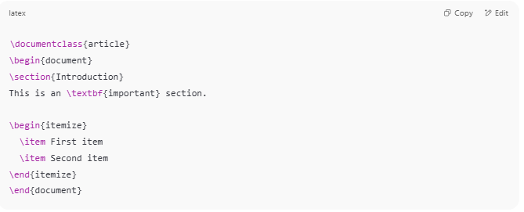
\documentclass{article}
\begin{document}
\section{Introduction}
This is an \textbf{important} section.

\begin{itemize}
\item First item
\item Second item
\end{itemize}
\end{document}

- \section{} creates a section
- \textbf{} makes text bold
- \begin{itemize}...\end{itemize} creates a list
These are commands that tell LaTeX exactly how to format and structure the document.

🧠 Procedural vs Descriptive/Semantic vs Presentational
# Source: AI Source: Provided by: [Data Path: Persons Table -> ID Column: 1, Name_En Column: Motasem Essam] -> From: [Chatgpt (GPT‑5 Mini)] on [1/26/2026]
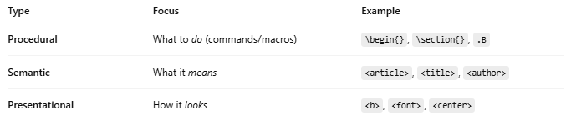
Type | Focus | Example
Procedural | What to do (commands/macros) | \begin{}, \section{}, .B
Semantic | What it means | <article>, <title>, <author>
Presentational | How it looks | <b>, <font>, <center>

✅ When to Use Procedural Markup
# Source: AI Source: Provided by: [Data Path: Persons Table -> ID Column: 1, Name_En Column: Motasem Essam] -> From: [Chatgpt (GPT‑5 Mini)] on [1/26/2026]
- You want fine control over document formatting (academic, print layout)
- You need dynamic content generation (like in reports)
- You want to use macros and automation inside your document

⚠️ Downsides
# Source: AI Source: Provided by: [Data Path: Persons Table -> ID Column: 1, Name_En Column: Motasem Essam] -> From: [Chatgpt (GPT‑5 Mini)] on [1/26/2026]
- Harder to learn than HTML or Markdown
- Less readable to non-technical users
- Mixing logic with content can reduce clarity

